|  |  |
| --- | --- |
|  | **2015** |
|  | Socio  Ayam Ajmera(1401096) Charvik Patel(1401079) |

Prof. Naveen Kumar Mentor: pooja bavishi

Problem Statement

We are going to make a project which is somewhat same as Facebook, Twitter, etc. Our project will consist of user making a profile for him/her, making friends, getting suggestions if they know friend’s-friend, create a page, search profiles of other people, etc. User has to make a profile and the profile details will be saved in a file. So we can create a different file for different user and store the details like email id, phone number, date of birth, address, workplace, city, etc. User can make friends, get suggestions about other friends, create page.

List of Data Structure

Array List :

Adjacency matrix or Object graph: For Linking Friends with Particular other user.

Trie Tree: Searching Profile.

Circular Queue : For Last 10 Login/Signup.

List of Operation on Data Structure

Adjacency Matrix: Adding the Node When Friend Request is Accepted.

Trie Tree: Search, Insertion.

Circular Queue: Dequeue , Enqueue , Display Last 10 Updates.

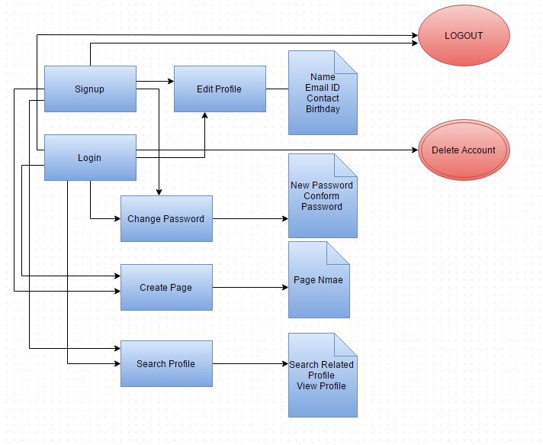

Book: Data Structure and Algorithm in Java, 2nd Edition, Robert Lafore.

Introduction to java Programming comprehensive Version,10th Edition ,Y. Denial Liang.

Website: <http://www.sanfoundry.com/java-program-implement-adjacency-matrix/>

<https://en.wikipedia.org/wiki/Adjacency_matrix>

<http://www.geeksforgeeks.org/trie-insert-and-search/>

References

/*In which File What is Contain

Example: Signup.java:-Sign-up Class And code of Signup of Account*/

List Of Program(File name of each program and single line for importance of that file.)

Flow Chart